Algebra 1: Unit 4, Lesson 5

- The graph of a line is shown.
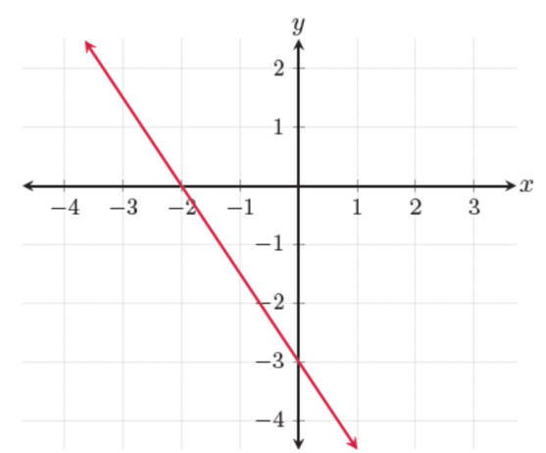
Is the slope of the line positive, negative, or zero?
negative

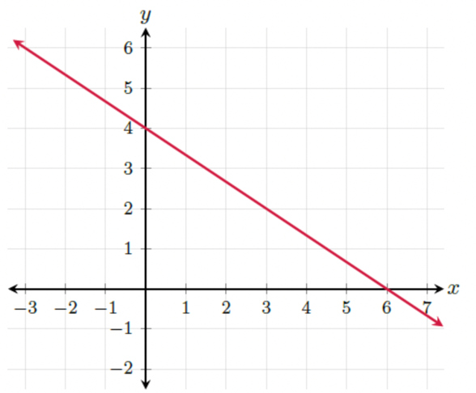
- The graph of a line is shown.
What does the $x$-intercept of the line?
4

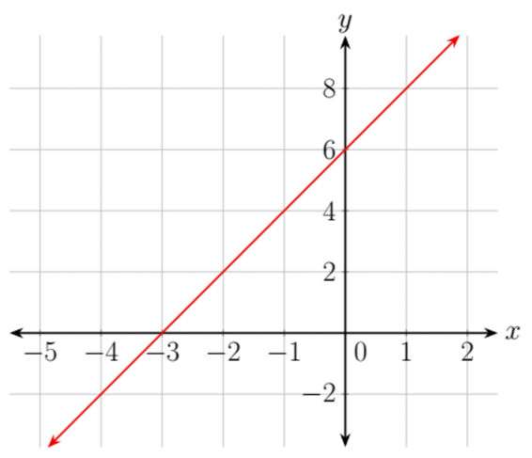
- The graph of a line is shown.

What does the $y$-intercept of the line?
6

